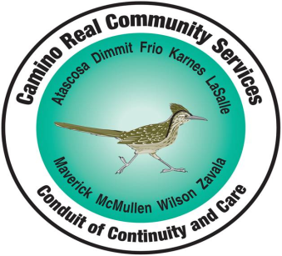

Camino Real Community Services
19965 F.M. 3175 North, P.O. Box 725, Lytle, TX 78052

Phone: (210) 357-0300 Fax: (830) 772-4305
Relay Texas: (800) 735-2989 (TTY) Crisis Hotline: (800) 543-5750

Veronica A. Sanchez, M.A., LPC-S, Executive Director

NOTICE OF PRIORITY POPULATIONS TO SUBSTANCE USE DISORDER TREATMENT

The Federal Department of Health and Human Services, Texas Health and Human Services and Substance Abuse and Mental Health Services Administration, require certain populations to have priority access to treatment services that are funded by Health and Human Services.

Priority access is required for:

- Pregnant individuals who inject substances of abuse
- Pregnant individuals in need of treatment for addiction
- Individuals injecting substance of abuse
- Individuals at high risk of relapse
- Individuals involved with the Department of Family and Protective Services (DFPS)

Individuals in one of the above categories will be screened for need of substance use disorder services. Available services for those who qualify may include detoxification services, residential treatment services, outpatient services and medication assisted treatment.

